Unit 4 – Lesson 8. Using SQLite with Fragments
Aim:
- How do we use SQLite with fragments?

Objectives: After the lesson, students will be able to:
- Obtain fundamental understanding of SQLite and fragments

CLASS PROCEDURE:

Do Now:
Find the Android examples I shared with you before, and if you cannot find it, the zip file can be found in the lesson note folder.

Open Android Studio, import the project named “Address Book” to the Android Studio. Run the project and explore the app. What are the functions for the app? Open the source code. How does the app use fragments?

Presentation / Discussion:
- What activity classes are used in the Address Book app?

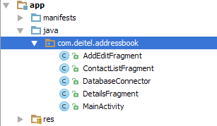

- What is fragment and why do we use fragments in android?

- A Fragment is a piece of an activity which enable more modular activity design. It will not be wrong if we say, a fragment is a kind of sub-activity.

- How do we use fragments with SQLite?

Pair – sharing Activity:
You and your partner(s) will use Android Studio and Java to create an APCS Quiz App. Here are the requirements:
1) You need to find 30 multiple choice APCS questions and store them into a SQLite database table.
2) The questions should be grouped by topics.
3) You also need to have a user table to track the user's scores and mistakes.
4) When the user starts the app, the app should allow the user to pick a topic.
5) After the user picks a topic, the app shall display the questions for the topic one by one, in random order.
6) The app should keep tracking the user's scores and display the final score by the end.
7) Your app should have sounds for "congratulations" and for "try again".
8) Your app should have user friendly UI.

